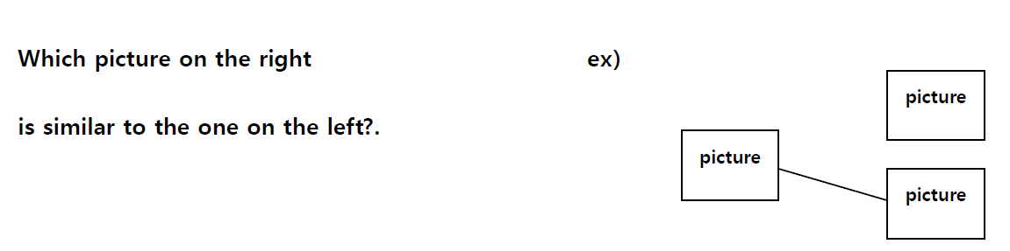
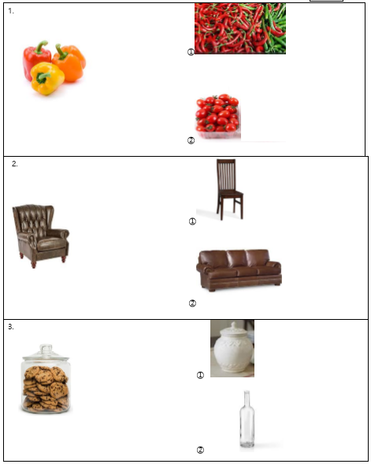
Answers
1.
2.
3.
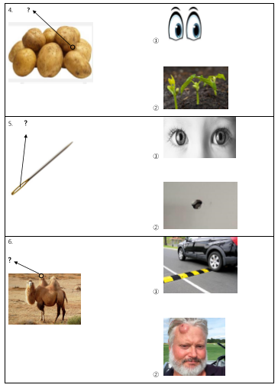
Answers
4.
5.
6.

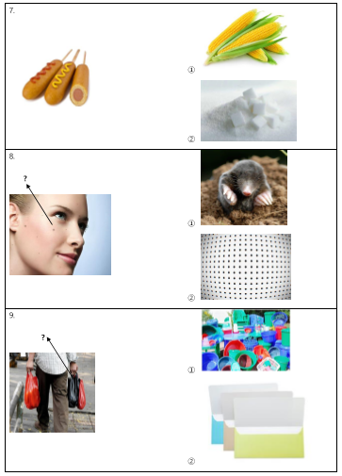
Answers
7.
8.
9.

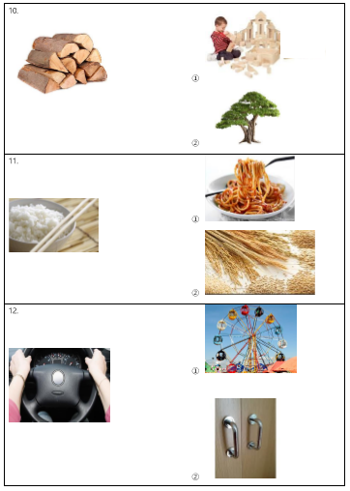
Answers
10.
11.
12.

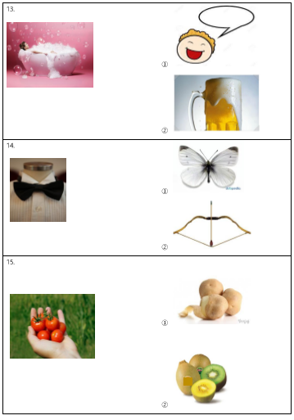
Answers
13.
14.
15.

Please write the name of the item in the picture
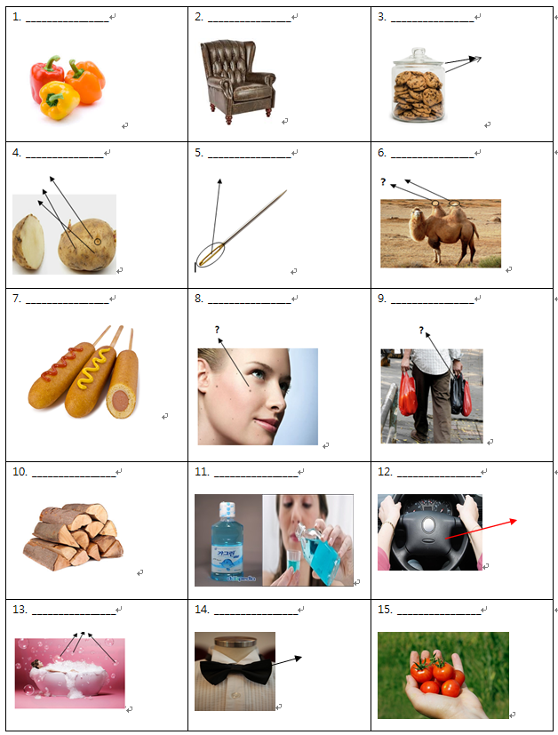
Answers
1.
2.
3.
4.
5.
6.
7.
8.
9.
10.
11.
12.
13.
14.
15.

Which description is better? (Choose 1st or 2nd description)
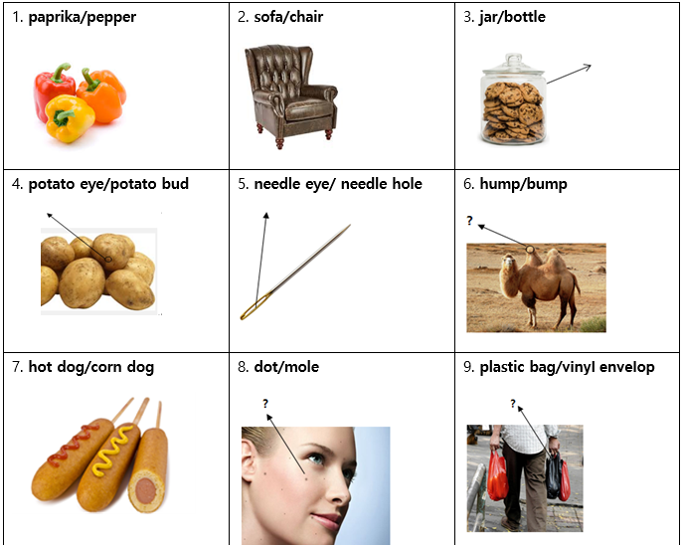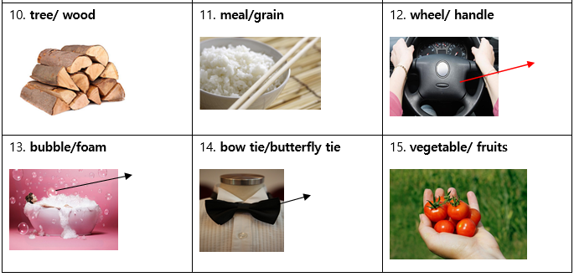
Answers
(1 or 2)

1.
2.
3.
4.
5.
6.
7.
8.
9.
10.
11.
12.
13.
14.
15.

