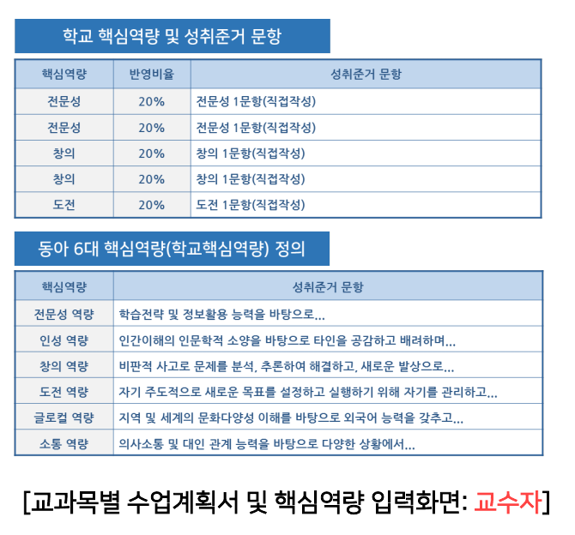
글로컬40%- 2 questions
ex) Students will be able to develop their intercultural competence
ex) Students will be able to improve English as a global language

소통60%- 3 questions
ex) Students will be able to communicative competence
ex) Students will be able to utilize effective communication strategies in English
ex) Students will be able to obtain interpersonal communication skills in English

